# IT2120 - Lab Sheet 10

Kavindya M.H.H-it24100343

Exercise 2

**R Code Used**

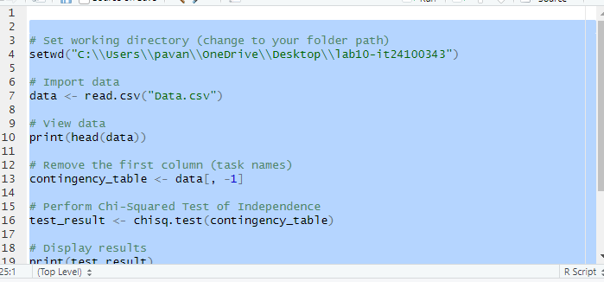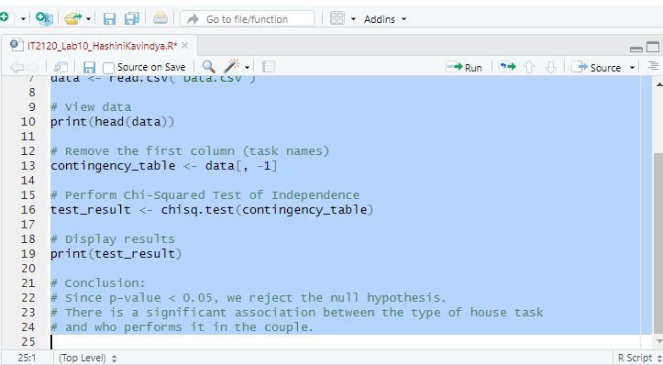

**Test Results**

Chi-square Statistic: 1944.46

Degrees of Freedom: 36

P-value: 0.0000

**Conclusion**

The chi-squared test shows that the p-value is less than 0.05. Therefore, we reject the null hypothesis. This means there is a significant association between the type of house task and who performs it in the couple.